Welcome to Wee Lad & Lassie  2023-2024  Hello Two’s Families,  Welcome to the two’s class at Wee Lad and Lassie! Ms. Stephanie and Ms. Lindsay will be returning as your child’s teacher. Ms. Stephanie and Ms. Lindsay both have their Associates Degree in Early Childhood from Anne Arundel Community college and are working on their Bachelor’s Degree in Early Childhood at Towson University. Ms. Stephanie and Ms. Lindsay are planning a year filled with excitement, discovery, and fun. A key focus of the two’s class is the social/emotional development of each and every child. We will aim to increase self-confidence, positive interactions, and self-regulation over the course of the school year. Each child will grow in early literacy skills and basic number sense. Each child will also become an inquisitive scientist as we explore the world around us. Additionally, we will work towards improving our fine/gross motor skills through sensory exploration and physical play. We are all looking forward to instilling a love of learning in each child and watching them grow with you!  Please drop in between 2:00 and 5:00 pm on Friday August 18th for a short visit to meet your child’s teachers. School begins on Monday, August 21st We look forward to seeing you then!  Sincerely,  Laurie Cloud  Assistant Director |   First day of school 8/21/2023  Current school hours for extended care  7:30-5:00  Please look for our monthly newsletter and calendar to be emailed to you monthly.  Open communication is very important to us. Please email us at weeladandlassie@verizon.net or call us 410-647-2178 if you have any questions or concerns.
Important Reminders  If your child stays for lunch:  - Remember that we are a nut free facility. You may substitute soy butter for peanut butter. Please clearly label that it is soy butter.  - All perishable items (milk, cheese, yogurt, etc.) need to be labeled with your child’s name and must be placed in a zip-lock bag. The rest of the items may be in the lunchbox labeled with your child’s name.  - Please note that we do not heat food at lunchtime.  If your child stays for naptime:  - Please send in a small pillow and blanket in a bag labeled with your child’s name. Reusable shopping bags work great! Nap items will be sent home every Friday to be laundered. Please return these items every Monday.  - You may also send in a small stuffed animal for your child to sleep with, if needed.  - A cot sheet will be provided for your child which will cost $9 and will appear on your first bill.  General Safety Rules:  - Please put sunscreen and bug spray on your child in the morning before coming to school. If your child stays all day we will reapply after nap. Please supply both items labeled with your child’s name if you would like us to reapply at school.  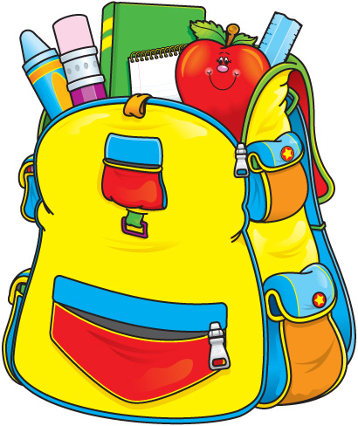  - Shoes with secure backs or tennis shoes are required for children to play safely on the playground. Flip-flops and Crocs are prohibited. | 2’s Supply List  - 1 package of Expo dry erase markers (4 count-any color)  - 4 boxes of Crayola broad tip markers (8 count-basic colors) or 4 package of Crayola “Pip Squeaks” markers (16 count)  - 2 boxes of Crayola large crayons (8 count-basic colors) or 2 boxes of Crayola Triangular crayons  - 3 bottle of Elmer’s washable glue  Please put all of the above  items in a large labeled  Ziploc bag. Individual items  do not need to be labeled.  - Diapers and wipes if needed  - Extra set of clothing (including socks and underwear) in a labeled Ziploc bag that is weather appropriate. Please update as the seasons change.

